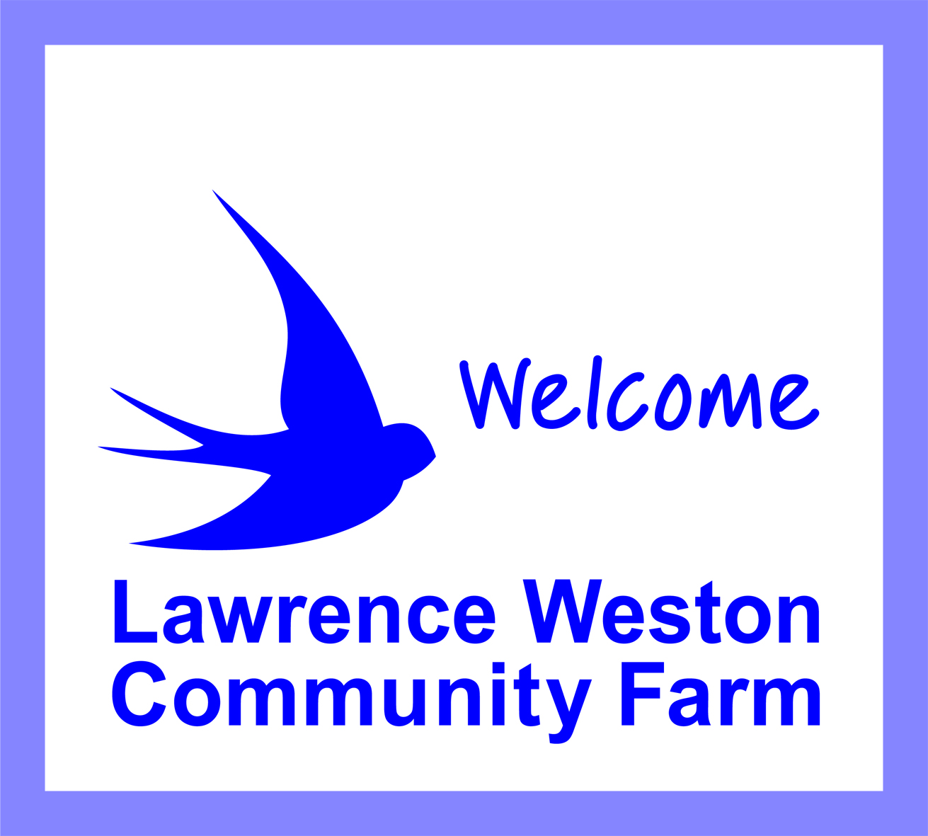

Saltmarsh Drive Lawrence Weston Bristol BS11 0NJ

0117 938 1128
www.lwfarm.org.uk
Lawrence Weston Community Farm

Community Farm Worker (Sundays)

Job Description

Job title: Community Farm Worker (Sundays)

Salary: £15,870 pro rata (7 hours per week)

Hours: Sundays 9.00am – 5.00pm

Accountable to: Chairperson of Management Committee

Reporting to: Volunteer/Livestock Coordinator & Farm Manager

Annual Leave: 36 days plus including bank and public holidays, pro rata 7 days

Location: Lawrence Weston Community Farm, Saltmarsh Drive, Lawrence Weston, Bristol, BS11 0NJ

Main purpose of the Job

To coordinate, and participate in, the daily routine of the farm on Sundays ensuring its safe, smooth and secure operation whilst also supervising and supporting young people to undertake volunteering activities.

Duties and Responsibilities

To coordinate and participate in the daily routine of the farm at weekends including feeding, watering and mucking out of animals and other duties as required.

To coordinate, supervise and support volunteers, placements and young people carrying out their volunteering activities.

To be responsible for the opening and closing routine of the farm including the movement of livestock to and from pens and paddocks, the prompt opening of the site in the morning and ensuring that all elements farm site are secure and locked as appropriate during the day and at the end of the day.

To ensure that the farm site remains fully operational, safe and welcoming e.g. free from rubbish, obstruction, dangerous objects or hazardous situations.

To ensure the care and welfare of all livestock, with support from the farm’s Volunteer & Livestock Coordinator as and when necessary.

With support from the farm’s Volunteer and Livestock Coordinator assist with birthing duties, health checks, preventative treatment as required.

To work with and assist the public, farm members, service users and other individuals and as appropriate. For example, welcoming and facilitate room hire and other bookings.

To work within and to promote the aims and objectives of the Community Farm, and to present a positive image of the Farm to the public.

To abide by all farm rules, policies, procedures and instructions issued by line manager and farm manager.

To undertake cleaning duties including the toilet facilities and ensuring that other facilities such as the Training Room, Community Room & Kitchen are clean and in good order following hire by members of public and other groups.

To ensure that the output and quality of your work is of the highest standards

To maintain records if required, report issues to line manager promptly and use established systems of communication with other members of staff to ensure the smooth running of the farm.

To carry out other duties commensurate with the responsibilities of the post, as required.
Registered Charity No. 1046563 Company Limited by Guarantee 3040752
Registered Charity No. 1046563 Company Limited by Guarantee 3040752
Registered Charity No. 1046563 Company Limited by Guarantee 3040752
Registered Charity No. 1046563 Company Limited by Guarantee 3040752
Registered Charity No. 1046563 Company Limited by Guarantee 3040752

