Job Pack: Senior Producer
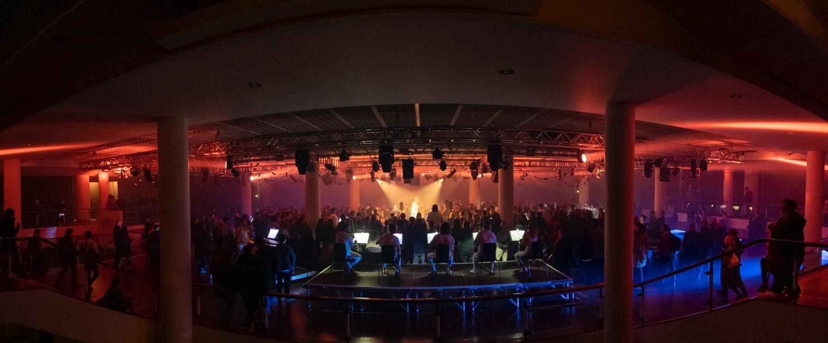
Thank you for your interest in working with Paraorchestra. This is an extraordinary moment to join our team following a rapid expansion of our programmes, projects, partners, funders and team.

Paraorchestra creates award-winning, high quality and innovative orchestral work presented as large-scale live concerts, shows and tours, recordings and broadcast programmes. Attending a Paraorchestra show offers a transformational and emotive experience. Our artistic ethos brings audiences up close and personal with the musicians and artists, immersing them in the experience and shattering traditional preconceptions of what an orchestra does, where you might encounter it, what it plays, and who performs. Because of this approach, we attract a predominantly new, younger, and more diverse audience.

“Buzzing from an immersive music/dance piece where the audience is able to wander about on stage brushing up against singers, strings, bass, percussion, dancers. Music up so close you feel the vibrations.”
Kirsty Lang, broadcaster,
The Nature of Why at Southbank Centre, London

We are as adept performing in concert halls, as we are in theatres, galleries, outdoor music festivals, beachfronts, and housing estates. Our touring has reached across England, Scotland and Wales. We work most closely with Bristol Beacon, where Paraorchestra is Associate Artists at one of the UK’s most prominent, forward-thinking, concert venues and regularly perform at London’s Southbank Centre.

Our repertoire mixes new commissions with the contemporary and traditional; Steve Reich, Górecki and Mozart, as well as re-imagined work based on the music of Kate Bush, David Bowie, and Kraftwerk.

Across our programme of concerts and events, we offer a vision of the inclusive change that we want to see in the world. Professional disabled musicians, composers, and artists are the backbone of our creative output with 60% of our professional ensemble having lived experience of disability.

“The orchestra can include everyone, and it can be for everyone.”
Charles Hazlewood, Artistic Director, Paraorchestra

Our new artist development programme Modulate, is creating change at a structural level within the classical sector, offering opportunities for disabled musicians and composers to explore their practice in multiple bespoke ways. The programme goes beyond notions of levelling the playing field and is creating an environment in which disabled music creators can truly thrive.

Perhaps the best way to get a feel for what we do is via this short film:

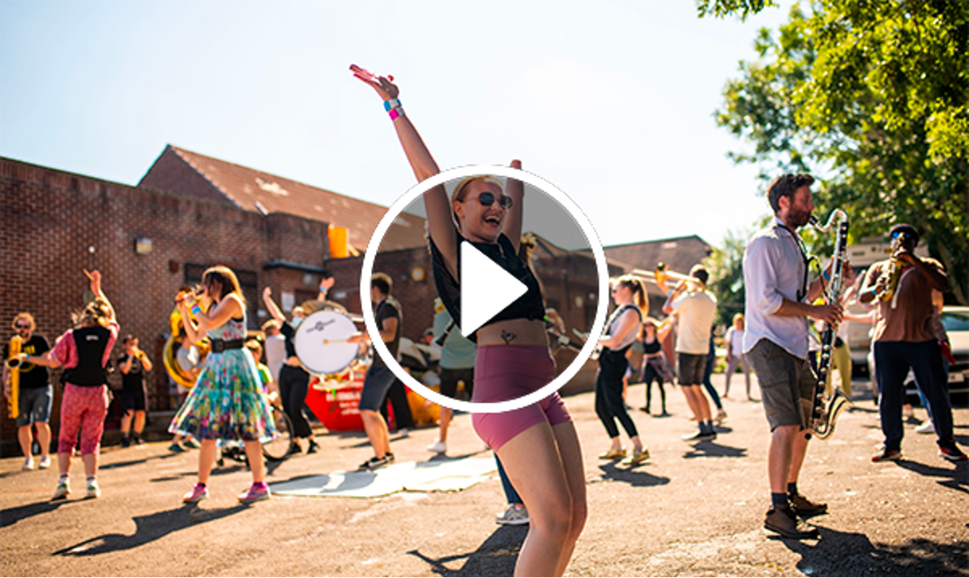
Click here for an audio-described version of the film

Here are some further examples of our work:

The Virtuous Circle (2024), a BBC Co-commission for the Bristol Proms reimagining the orchestral format as an immersive experience with Mozart’s 40th symphony at its core as well as a team of professional dancers and new compositions by Ivor Novello award-winner and Paraorchestra member Oliver Vibrans.

Trip The Light Fantastic (2023), a three-way collaboration between Paraorchestra, Bristol-based electronic composer Surgeons Girl and AV specialists Limbic Cinema commissioned by Bristol Beacon to celebrate the reopening of the venue after its once-in-a-generation transformation.

SMOOSH! (2021), a large-scale outdoor site-specific promenade performance of up to 70 professional and local musicians and dancers that is typically performed in and in co-creation with communities who do not traditionally attend concert halls.

Two TV projects: Beethoven and Me (2021), watched by 146,000 people, and which won Best Music Programme at the 2022 Broadcast Awards and Re-Inventing the Orchestra (2022), an unprecedented six-part documentary series, watched by 233,000 people.

The Unfolding (2022) our debut album, a collaboration with composer Hannah Peel released worldwide by Real World Records reached Number 1 in the Classical Album Charts and toured to Bristol, Gateshead, Edinburgh, London culminating in a headline performance at the Bluedot Festival near Manchester.

The Anatomy of the Orchestra, our sound installation for 65 musicians allows audiences to wander the orchestra up close and personal, continues to be in demand and was presented at the opening of the redeveloped Birmingham Symphony Hall in Summer 2021, and at Southbank Centre Summer 2022. A new iteration, Drone Refractions, premiered at Bristol Beacon and Southbank Centre in January 2024.

How we work
We are a passionate and openhearted team of people who are excited by the art we create and driven by the changes and opportunities we are initiating.

We take a person-centred approach when creating each of our projects, consulting with every musician or creative involved to ensure we remove any barriers that might prevent them performing at the highest level. Our collaborations with artists across genres and artforms, together with our ensembles of disabled and non-disabled musicians, are deepening levels of understanding, and encouraging an exciting and unique exchange of ideas and creative opportunities.

“I have felt so supported and welcomed during my start at Paraorchestra. It’s so lovely to be part of a team who treat each other with such kindness, trust and respect. Everyone was well prepared for my first day, the onboarding process has been faultless and I felt like part of the team straightaway.”
Holly Beasley-Garrigan, Artist Development Coordinator
(joined January 2024)
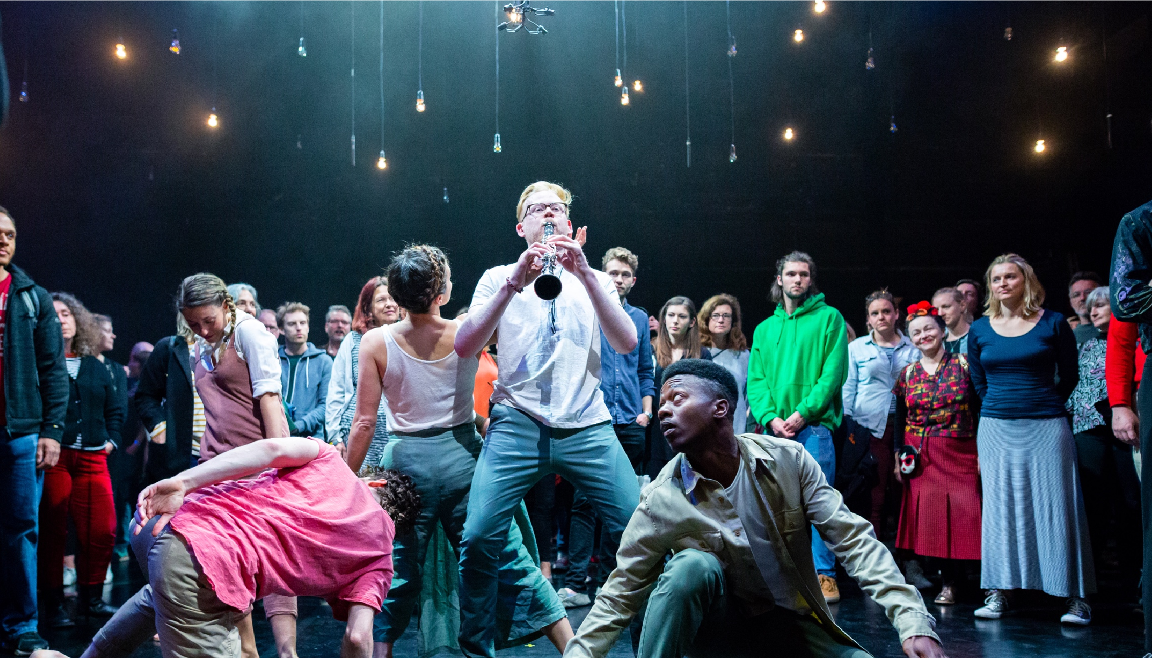
This whole ethos is extended throughout the team. We work collaboratively, with respect and consideration, nurturing a culture where no question is a ‘stupid question’ and everyone is equipped to enjoy, and take pride in, their work.

Access Support and Inclusivity
We believe all areas of our work will be stronger with greater diversity and welcome applications from those who bring difference.
We recognise that the arts have not been a go-to employer for anyone who identifies as disabled. We want to act positively and change this and would like to hear particularly from those that identify as D/deaf, disabled or neurodivergent under the Social Model of Disability or who have faced barriers to their career progressing due to access needs not being met.
If you are D/deaf, disabled or neurodivergent and you meet the essential criteria for the role, we will guarantee you an interview.
We are also able to support you with an application to Access to Work where appropriate. If you would like to discuss this before an application please email applications@paraorchestra.com and let us know how best to contact you.

“I joined Paraorchestra as Producer in 2023 and have loved every minute! The organisation has a wonderful approach to creating work in an ambitious and caring way, not sacrificing one for the other. And this applies to the way they look after their staff too, the systems and processes in place support a great work ethos of trust and collaboration. I have felt really well supported by my team and line manager. I have worked in the industry for 15 years and can honestly say I have never worked for such a caring (and efficient!) organisation.”
Ailie deBonnaire, Producer
(joined June 2023)

Applications

To apply, please send a CV and covering letter explaining how your experience, skills and personal attributes are right for the role to applications@paraorchestra.com

Please pay particular attention to the key responsibilities and the person specification, as matching these to your skills, experience and attributes is how we determine our shortlist for interviews.

Your covering letter can be a video or an audio file (no longer than 4 minutes) or written (no more than 2 sides of A4).

Please download and return a completed Equal Opportunities Survey along with your application.

If you need access support to complete and submit your application, please email applications@paraorchestra.com and let us know how best to contact you.

Here are some application Dos and Don’ts to bear in mind:
- DO include your phone number and contact details
- DO include dates on your work history
- DO tell us how you heard about the job
- DON’T include a photo or your date of birth – this is confidential data you don’t need to share with us
- DON’T forget to proofread for spelling and grammar errors

Interview Process and Key Dates

The deadline for applications is 10am Monday 23 September 2024

Interviews will take place on Tuesday 1st October 2024

If your application is successfully shortlisted and you are invited to an interview, we will provide interview questions in advance, along with an organisational chart outlining all of the different roles in the organisation. Please be forthcoming with any access needs ahead of your interview so that we may accommodate them.

Interviews are likely to be held in person in Bristol, however, we are also happy to facilitate a Zoom interview with the panel if this works better for you. In certain situations we may decide to hold all interviews online using Zoom. If the interviews are held in person, we are happy to reimburse your travel expenses, and any additional access costs that you might have.

Feedback

If you are invited to interview but are unsuccessful we will provide feedback – on request – within two weeks of your interview. This may be verbal or written. We are unable to offer feedback on your initial application alone due to the high number of applications that we receive. If you have not heard from us within three weeks of the deadline, you can assume that on this occasion you have been unsuccessful.

Questions?

If you have any questions about the recruitment process, or would like to understand more about our culture, we can arrange an informal chat with one of the newest members of the team about their experiences to date and what it’s like to work for Paraorchestra.

Please get in touch on applications@paraorchestra.com. This is an opportunity for you to learn more about how we work, rather than the specifics of the role advertised, and you will not be talking to a member of the interviewing panel.

Thanks again for your interest in the role and we look forward to reading your application.
Warm wishes,

Jonathan Harper
Chief Executive Officer
Paraorchestra

Position: Senior Producer

Reports to: Programme Director (Deputy CEO)

Manages: Producer, Orchestra Manager,
Production Manager, Project Team

Terms: Permanent, full-time (40 hours per week)
£39,500 per year + contributory pension
25 days leave (plus statutory public holidays)
Location: Bristol/ Hybrid

The Role

We seek a motivated Senior Producer to lead the strategy and delivery of the artistic projects within the producing team. Working closely with the Artistic Director and Programme Director the Senior Producer will oversee the successful delivery of large-scale artistic projects including new commissions, touring, remounts, and work for broadcast TV and recordings. The Senior Producer will be responsible for leading our projects across concert halls, festivals, community based site specific locations and in music venues, nightclubs, shopping malls and beachfronts.
The Senior Producer will be pivotal in nurturing and building relationships with stakeholders and partners to deliver this ambitious and expanding artistic programme.
The role includes significant line producing responsibilities, as well as appointing and managing a number of freelance and employed line producers.

Key responsibilities:

Strategic
- To work closely with the Programme Director and Artistic Director to shape the strategic long term development of the artistic programme.
- To lead on the implementation and delivery of the artistic programme for the Paraorchestra.
- To support the Programme Director with the organisation’s annual business planning, feeding into conversations around dates, resources and feasibility, including for funding applications.
- To work alongside the Programme Director to seek out and develop new relationships with venues, festivals, co-producing partners and promoters, across the subsidised and commercial cultural sectors and in local communities.
- To develop and build partnerships in Arts Council England’s Levelling Up for Culture locations enabling us to deliver on our commitment to co-create and present work across the UK in these key locations.
- To manage relationships with freelance bookers as well as continuing to seek out opportunities for work to be presented both nationally and internationally.
- To work with the Senior Producer (Artist Development) and Associate Music Director to identify opportunities to work collaboratively across the programmes of work.
- Work with the Programme Director to develop a framework of evaluation for artistic projects and lead on the implementation of this.

Producing
- To ensure that projects are planned and delivered with appropriate provisions for the holistic range of requirements that disabled artists require and to regularly review best practise with the team.
- To lead the project team to develop a series of resources to support artistic, venue and/or festival partners to understand and make appropriate positive provisions for the holistic range of requirements that disabled artists required.
- Lead on negotiations and contracting for artistic projects.
- Review and set artist and project team fees using industry guidelines including Musician Union rates with the Orchestra Manager.
- Responsible for setting up templates and reviewing contracting across projects.
- Managing a team to deliver projects of scale as well as taking line producing responsibilities when required.

Financial
- To ensure that financial viability of new commissions and touring projects are rigorously tested, outlining key risks to the Programme Director.
- Develop and manage project budgets, cash flow and schedules, communicating regular updates with Programme Director.

Management
- To excel in the line management of the Projects team, supporting and nurturing direct reports to fulfil their potential and deliver the goals of the organisation
- Recruit and manage freelance producers and production staff as per the requirements of each project and the organisation.
- To support an efficient flow of information between the producing team and colleagues in marketing and fundraising, with a view to increasing audience numbers to events and funding into the organisation.
- Ensure that all artistic projects and relevant team members are following policies in terms of the following: safeguarding; health and safety; equal opportunities; GDPR; environmental sustainability.
- To be an advocate for the organisation’s role as an ‘agent for change’ in the cultural sector.
- To embed access within projects as well as researching and seeking out opportunities for Paraorchestra to trial, develop and feed into research in the area.
- To take an active role in supporting Paraorchestra’s aim to reduce its carbon footprint annually, working with colleagues to deliver the Carbon Footprint Reduction action plan which impacts on delivery of projects across travel, catering, accommodation and production.
This list of responsibilities is not exhaustive, and the Senior Producer may be required to perform duties outside of this as operationally required and at the discretion of the Programme Director.

Person specification

Essential experience, skills and knowledge

- At least five years’ experience producing mid or large-scale projects in either the music or performing arts sector, from early stage through to realisation and implementation
- Experience of touring within the UK or working at a festival or venue receiving work
- Experience of producing projects including non professional participants
- Excellent line management experience, with the proven ability to lead and motivate teams of colleagues
- Successful experience of project management and keeping team members updated and on-track with project requirements
- Exceptional financial management experience relating to large-scale artistic work, and proven experience of effectively managing a project from start to finish
- An ability to build trust and confidence quickly in order to successfully negotiate with multiple partners and suppliers at any one time
- An understanding of health and safety risk management when implementing large-scale projects
- An understanding of the requirements for marketing and PR staff when formulating PR and marketing/audience development strategies for artistic projects
- A good knowledge of the arts sector
Essential personal attributes
- The ability to effectively manage a team, with the confidence to make decisions independently when necessary
- Excellent organisational and time management skills
- Motivated to support and shape creative projects
- Excellent attention to detail
- Passionate about effecting change within the arts and culture sector
- Able to represent the organisation professionally at events, conferences and meetings
- Able to work calmly whilst under pressure, with the ability to know when best to seek support and guidance from senior managers
- An understanding of The Social Model of Disability

Desirable:

- Experience of working with and supporting disabled artists
- Knowledge and experience of touring work internationally, ideally with international festival partners
- An understanding of best practice in safeguarding
- Experience of producing education projects either in the music or performing arts sector, from early stage through to realisation and implementation
- Experience of co creating and developing work with a range of different communities and audiences
- Experience presenting work in ACE Priority Places or levelling up for culture places

Summary of main terms & conditions

Working conditions

Paraorchestra seeks to offer a working environment that is flexible and responds to a wide range of employee needs.

You will see our approach to this laid out below. We will always need to balance this with our mission as an artistic organisation, to create and tour large scale work in the UK and internationally. Requests for flexibility will be considered alongside Paraorchestra’s need for employees to fulfil the function of their roles, which means that on occasion, we will not be able to agree to all requests for flexible working.

Employees requesting reasonable adjustments for access needs will be discussed and dealt with separately to the flexible working process.

Contract

This is a permanent full-time contract, subject to a six month probation period

Salary

£39,500

Annual Leave

25 days Annual Leave plus UK statutory bank holidays

Hours

This is a full-time role working 5 days per week (8 hours per day) between Monday to Friday, which are inclusive of a one hour paid lunch break, and can be worked flexibly between the core hours of 8am and 6pm.

Whilst the majority of your work will need to be undertaken during our core hours, you may also be able to propose working some of your hours outside of our core hours, based on your access needs or existing family commitments. We are open to discussing this, and you should raise this in your application.

We have reviewed this role internally and believe it needs to be a full time role. If you wish to propose delivering this role in less hours than we are advertising, owing to your access needs or existing family commitments, this may be possible to facilitate. Please be forthcoming in your application to us if this is the case.

You may be required on occasion to work some evenings and weekends. If you are required to work additional hours you may be entitled to time off in lieu (TOIL).

Location
Our preference is for you to be based in Bristol and its surrounding area and to have an office presence for a minimum of two days each week. The role will involve some national travel.

Paraorchestra offers hybrid working for all employees. This means that it may be possible for you to work remotely from time to time.

Notice Period

Following successful completion of the probationary period, the period of notice will be 3 months on either side.

Pension
Paraorchestra operates a NEST stakeholder pension scheme, where the employer contributes 4% and employee contributes 5% of your salary annually.

Other Benefits
Paraorchestra offers enhanced paid leave (following qualifying periods) across Sickness Leave, Parental and Dependents Leave, Maternity and Adoption Paid Leave, Paternity Leave and Bereavement Leave. The details are as follows:
Sickness
6 weeks on full pay, with an additional Exceptional Circumstances clause offering 12 weeks on full pay followed by 12 weeks on half pay.

Maternity/ Adoption
12 weeks on full pay followed by 12 weeks on half pay, and statutory thereafter

Paternity
3 weeks of paid leave which can be taken as a block or separately, on full pay.

Time off to care for dependents
A supportive environment for its employees with dependents, with 5 days paid leave available.

Bereavement
4 weeks on full pay in the event of bereavement of a child under 18 years of age or a spouse or partner, and 2 days in the event of a close relative.

