
Female* Recovery Navigators
(Assessment & Recovery North Team; Community based role)

We have rewarding opportunities available for Female Recovery Navigators to join our teams based in North Bristol. You will join us on permanent contract working 37.5 hours each week on a rota system and in return, you will receive a competitive salary of £25,359 - £27,449 per annum and benefits.

Missing Link provides practical advice and support to individuals to allow them to maintain a rich and meaningful life. The aim is to deliver recovery and wellbeing opportunities for people with mental health and other support needs to achieve their hopes and ambitions.

In return for joining us, we will offer you:

- Up to 30 days annual leave (depending on length of service)
- 3 extra holidays including International Women’s Day
- Excellent development and training opportunities
- Employer pension contribution (minimum 5% of your gross salary)
- Mindful Employer Plus Scheme
- Cycle to Work Scheme
- Long Service Awards
- Staff Recognition Awards

About the role:

As our Recovery Navigator, you will work collaboratively together with the service user (you will support female and male service users) and mental health professionals to navigate and coordinate services (both social and clinical interventions), connecting into community resources, building resilience and improving wellbeing. Work within a recovery and psychologically informed approach, taking a holistic view to support people’s recovery to live fulfilling lives. Ensure that services are tailored to individual’s cultural and social needs.

Key duties and responsibilities of our Female Recovery Navigator:

- Build trusting and collaborative relationship with the service user (male and female)
- Co produce, implement and review recovery plan, crisis plan and other self-management tools e.g. Wellness Recovery Action Plan, in partnership with service users in line with best practice
- Case manage and co-ordinate support, referring and liaising effectively with all professionals, agencies and other parties involved in service user’s support in order to deliver the support package
- Work closely with colleagues with the service and build strong partnership working with other agencies such as Health and Social Care, Voluntary and Community Service. Support/ facilitate service users to access services
- Provide specialist support to women using the service and advice and guidance to other team members regarding women’s mental health issues
- Provide specialist support and screening regarding domestic abuse/sexual violence and provide advice and guidance to the team on pathways into DVA and sexual violence services
- Promote and facilitate service user involvement and inclusion within Mental Health Bristol and the community in line with Mental Health Bristol Partnership objectives
- Manage caseload (male and female), documentation and time effectively, ensuring up to date and clear record keeping in line with BMH policies, making best use of supervision, training and staff development. Ensuring up to date and clear record keeping in line with policies
- Maintain hope and optimism for the individual with high expectations for recovery. Use lived experience (if appropriate) to positively support the individual’s recovery

What we are looking for in our ideal Recovery Navigator:

- Numeracy and literacy to GCSE level/NVQ 2 or equivalent
- IT skills including ability to produce various documents in Word, and use of email and internet
- Proven knowledge of support needs of people with mental health needs
- Proven knowledge of equal opportunities issues
- Proven knowledge of health and safety issues, especially those relevant to mental health
- Proven knowledge of safeguarding policies and procedures relating to adults and children and young people
- Knowledge and understanding of the particular needs of working with vulnerable women and men
- Experience working with people with mental health needs, or people with complex needs
- Proven experience of carrying out needs and/or risk assessments and the support planning process
- Hold a full driving licence and have access to appropriate motorised vehicle (desirable)

Please apply now to join us as our Recovery Navigator and contribute to the valuable work Missing Link and its Partners do.

How to apply:

Please download the application pack from our website and complete the application form. Please submit your application by 9am Tuesday 16th July 2024. Please do not send CVs. Interviews will be held on Tuesday 23rd July 2024.

HR.Enquiries@missinglinkhousing.co.uk www.missinglinkhousing.co.uk

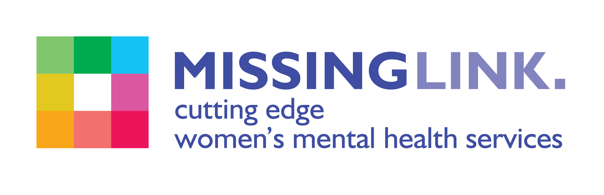
Missing Link is committed to safeguarding and promoting the welfare of children, young people and adults at risk of abuse, and expects all staff and volunteers to share this commitment. Missing Link is committed to Equal opportunities. *Due to the specific requirements of this role, this post is exempt under the Equality Act (2010), Part 1, Schedule 9 (Genuine Occupational Requirement)

