Play Support Worker Job Pack
This post is restricted to women only as a genuine occupational requirement under Schedule 9 of the Equality Act 2010
Hours and pay
14.5 hours per week to be worked as follows:
Day | Hours | Pattern | Location
Monday | 2.5 hours | 9.45 to 12.15 | Staple Hill
Tuesday | 2.5 hours | 9.45 to 12.15 | St George
Wednesday | 2.5 hours | 9.45 to 12.15 | Hartcliffe
Thursday | 4.5 hours | 9.30 to 11.30 and 12.30 to 3.00 | Bedminster
Friday | 2.5 hours | 9.45 to 12.15 | Patchway
 | 14.5 hours

£23,893 FTE (£12.38 per hour) based on skills and experience. Temporary Fixed term contract 6 months with the possibility of an extension.
Office Location: Mothers for Mothers, The Gatehouse Centre, Hareclive Road Bristol BS13 9JN. Some working from home may be required. The post holder would need to be able to travel to the group sites independently.
Reporting to: Groups Co-ordinator / Operations Manager
Accountable to: Chief Executive Officer
Main purpose of the role:
• To actively participate in the delivery of a high standard of quality play alongside physical, emotional, social, and intellectual care provision for babies and/or children attending Mothers for Mothers support sessions.

• To provide stimulating activities, engaging with children in a safe environment.

• To be aware of the high profile of the Mothers for Mothers settings within the perinatal mental health and infant emotional development pathway and to uphold standards at all times.

• To maintain links and work in partnership with the Mothers for Mothers team, parents, carers and professionals to promote the well being of the children.

• To work enthusiastically and flexibly as part of a team and to communicate effectively with team members.

• To build relationships of trust with our clients, ensuring they feel highly valued and at the core of our charity.

• To communicate in a calm, friendly non judgmental manner with clients demonstrating an ability to empathise, encourage and support women towards recovery.

• To signpost other organisations and resources that may be of benefit to families.

• To answer post, telephone calls and emails in a sensitive and professional manner.

• To promote Mothers for Mothers services appropriately.

• To collect and collate data from evaluation and monitoring forms. Write reports giving feedback on the service to the CEO and project funders.

• To work in close collaboration with Mothers for Mothers colleagues and to always act in the best interests of Mothers for Mothers.
Accountability:

The duties and obligations outlined are a guide to the current and main responsibilities of the post; they will inevitably vary and develop and the role specification will be reviewed. Changes will be subject to consultation with the post-holder. The post-holder will be required to agree and review annual objectives with their manager.

Working with:
- Babies and Children
- Clients
- Mothers for Mothers staff / volunteers
- Key external contacts and partners
- (including other VCSE services and Health Care Professionals)

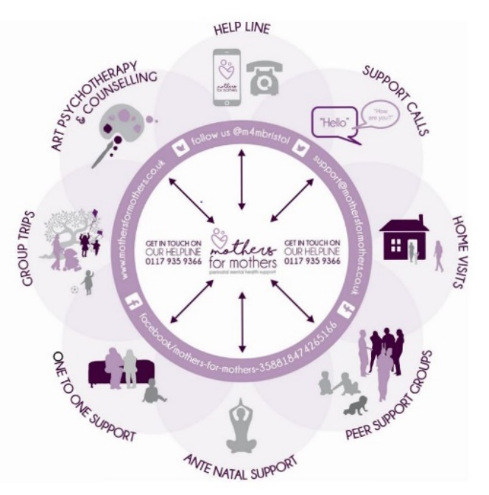
About Mothers for Mothers
Since 1981 Mothers for Mothers has supported families by offering maternal mental health and wellbeing support, advice and information to women, birthing people and their families in Bristol, North Somerset and South Gloucestershire. As mothers who have lived experience of depression, anxiety and isolation during pregnancy or after the birth our one or more of our babies, we understand how hard early parenthood can feel and how difficult it can be to ask for help.
We offer support during pregnancy and until their youngest child attends school, through our support services: Reach helpline/support calls, Home Visiting, Art Psychotherapy and Counselling, Peer Support Groups, Antenatal Support and SEND support. Our services are delivered by recovered women with lived experience.
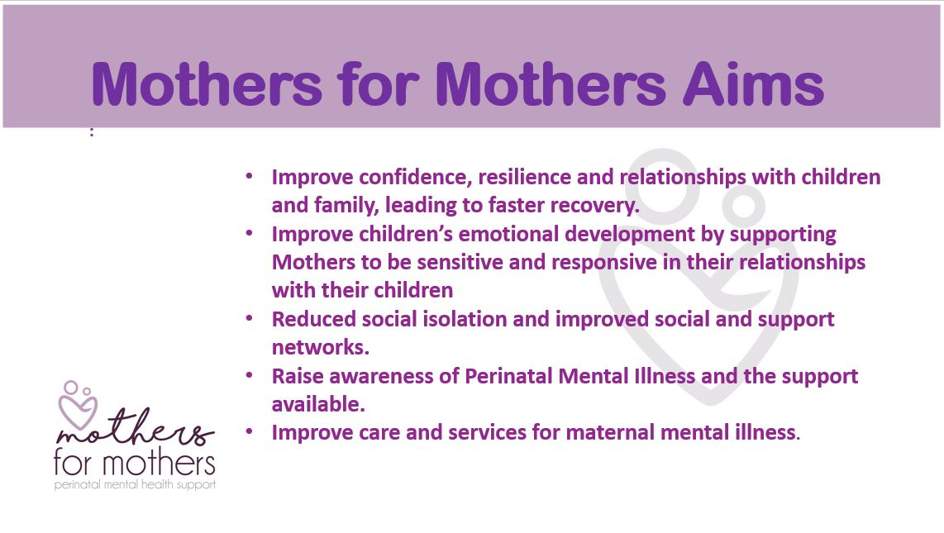

Job Description:
Principal Duties and Responsibilities

1  2  3  4  5  6  7  8  9  10  11  12  13  14  15  16  17  18  19  20  21 | To support the Group Co-ordinator in the directed planning and implementation of the daily activities of the session to ensure children's needs are met and to ensure their wellbeing at all times. This will include planning and participation in the regular groups delivery and in group trips and events throughout the year.  To ensure that risk assessments are completed prior to commencing activities with children. The Group Co-ordinator and Play Support Worker are required to risk assess each room used for every group and document it on each occasion using the correct paperwork.  To arrange and prepare the room for the appropriate age group expected at the session. Provide a purposeful, stimulating environment that is inviting and rich in learning opportunities (both indoor and outdoor when available). To maintain the activity area during the duration of the group session.  To support the children through safe, creative, varied and appropriate play opportunities, ensuring play is child led. Activities to take into account children’s abilities, interests, language, cultural backgrounds, specific needs and stage of development taking account of diversity and promoting equity and inclusion. To be constantly aware of the needs of the children during the session.  To work alongside the group team to ensure that positive relationships are built with children and their families, improving confidence, resilience and relationships between mothers and their children.  Work as a team to improving children’s emotional development by supporting mothers to be sensitive and responsive in their relationships with their children. Provide opportunities to extend interests by encouraging and supporting access to further activities and resources outside of the group setting.  Welcome visiting therapists and encourage clients to access the therapy on offer by looking after the individual’s child/ren until client comes back in the room.  To offer the children fruit snacks and water, promoting healthy eating. Ensure that food preparation and handling within the Setting is carried out within the guidelines of the Food Safety Act 1990 and Food Hygiene Regulations 2006.  To offer evidence based/good practice advice on sleep, feeding and other infant developmental issues. To provide signposting to additional information as required.  To implement and support national and local guidelines in order to safeguard and promote the wellbeing of children. To actively promote and support the safeguarding of children and young people in the workplace, ensuring that all staff and volunteers observe Mothers for Mothers policies and procedures to keep children safe from harm at all times.  Maintain clear confidential records on Substance Views database as appropriate. To support the group coordinator ensuring that all relevant records are maintained.  To monitor the service for current funders and future funder opportunities. Currently we monitor for Children In Need every 3 months through observation. Observations include improved family relationships, increased confidence and having fun! Prepare a Case Study on a quarterly basis.  To assist with the preparation and maintenance of materials and equipment.  Report and recording any accidents in the accident book in accordance with Health and Safety policies.  Respect the confidentiality of the setting and maintain high standards of conduct. Work within and implement all Mothers for Mothers policies, such as Confidentiality, Safeguarding, EEDI.  Contribute as appropriate to any Mothers for Mothers publications/publicity such as newsletters, website, information leaflets and displays as appropriate to the role.  Update, share information and work collaboratively within the staff team to include attending and participating in team meetings and team training.  To participate in activities which fall outside of normal working hours as required, e.g. training, staff meetings, team days, fundraising events, promotional events and public meetings etc.  Participate in monthly Clinical Supervision sessions.  To be able to travel to the group sites independently.  This job description is a guide to the duties you will be expected to perform immediately on your appointment. It is not an exhaustive list, and such duties may well be altered from time to time to meet changes in requirements. Any such changes will be discussed with the postholder prior to the changes being made.

Review of this Job Description
This job description is intended as an outline indicator of general areas of activity and will be amended in the light of changing service needs. This job description is to be reviewed in conjunction with the post holder on an annual basis.
Safeguarding
At all times promote and maintain the safety of children by working according to the Mothers for Mother’s Safeguarding Policy and supporting guidance. Being pro-active and responsive to safeguarding concerns by early reporting, recording and referral of issues to the Safeguarding Lead. Attending safeguarding training that is appropriate to your role.
Confidentiality
The post holder will maintain appropriate confidentiality of information relating to the Mothers for Mother’s, individuals and client information. The post holder will be expected to comply with all aspects of the Data Protection Act.
Equality & Diversity
Mothers for Mother’s is committed to achieving equality of opportunity for all staff and for those who access our services. You must work in accordance with equal opportunity policies/procedures and promote the equality and diversity agenda of the organisation. Mothers for Mothers has a zero tolerance policy which must be adhered to.

Risk Management / Health and Safety
Employees must be aware of the responsibilities placed on them under the Health & Safety at Work Act 1974, ensure that agreed safety procedures are carried out and maintain a safe environment for employees, patients and visitors. Mothers for Mothers operates a non-smoking policy at all venues and places of work.
Records Management
The post holder has responsibility for the timely and accurate creation, maintenance and storage of records about the service in accordance with Mothers for Mothers policy, including email documents and with regard to the Data Protection Act and any other relevant statutory requirements.
Policies & Procedures
Mothers for Mothers employees are expected to follow organisational policies and procedures. Copies of Mothers for Mothers policies can be accessed via the Administrator

Person Specification

Please ensure that you read the person specification carefully, as this will be used as part of the shortlisting and interview process.

Minimum required standard E = Essential, D = Desirable

Training & Expertise | Essential | Desirable
Relevant Childcare Qualification | X
First Aid Qualification |  | X
Experience of working in a childcare setting | X
Oral and written communication skills | X
Able to work within a team and maintain good communication | X
Safeguarding Training |  | X
Training in Peer Support work from recognised body / organisation |  | X
Lived experience of Maternal Mental Illness |  | X
Use of clinical supervision appropriately |  | X
Liaising with Health Professionals and other Mental Health Services |  | X
Skills
Enthusiasm for working with infants | X
Interest in the care and development of infants and in infant emotional wellbeing | X
Patience | X
Active Listening Skills | X
A non-judgemental, client centred, holistic, and trauma informed approach to working with families | X
Ability to plan activities and use of resources | X
Able to think clearly under pressure | X
Good understanding of boundaries: the limits of your capabilities and of what MFM can offer within the constraints of the service | X
Strong written, verbal communication and interpersonal skills | X
Administration, record keeping and IT skills proficient in all Microsoft packages including Word, Excel, PowerPoint, plus database and internet usage skills. | X
Understanding and experience of using social media digital communication channels to maximise communications impact. You will have the ability in creating appealing posts and responding appropriately to engagement. |  | X
Other Behaviour and Job Related Characteristics
Understanding of discrimination within the mental health system | X
Commitment to a woman-centred approach to services (which account for the impact of psycho-social / cultural issues) | X
Willingness and ability to meet monitoring and evaluation requirements | X
Understanding of and commitment to equity, equality, inclusion, valuing diversity and anti-discriminatory practice | X
Punctuality, reliability, trustworthiness | X
Awareness of duties and responsibilities within health and safety and food hygiene requirements | X
Awareness and responsibilities within Safeguarding requirements | X
A professional, proactive, positive, motivated and enthusiastic approach with a strong work ethic and “can do” attitude. | X
Capable of handling challenging situations while maintaining a positive demeanour | X
Caring, friendly and non judgmental approach to clients | X
Ability to work cooperatively with a broad range of individuals, inquisitive by nature with the ability to work across the services to ensure a joined up team approach. | X
Highly self-motivated and proactive, with strong time management, self-administration and organisational skills and the ability to meet deadlines | X
A proactive and flexible approach with the ability to work independently and act on initiative where appropriate | X
Able to exhibit excellent discretion and integrity and adhere to professional standards and confidentiality. | X
Exceptional attention to detail. | X
A positive approach to learning and gaining new skills through teamwork and training opportunities | X
Willingness to work some evenings to meet the needs of the role as required. | X

Application Form
Post: Play Support Worker
Closing Date: 1st September 2024
Interviews will be held w/c 02/09/2024
Advertising: Please state where you saw this job advertised ______________________
CONFIDENTIAL -Personal details:
Title:
Name:
Address:

Postcode:
Telephone:
Email:
DBS information:
Date of Birth:

When would you be available to take up the post?

Employment history:
Current Employer/organisation | Start Date | Job Title | Salary | Notice Period | Brief description of Duties

Previous Employers/Organisations | Start/Finish Date | Job Title | Salary | Brief description of Duties | Reason for leaving

Qualifications and Training:
Please list most recent first (including any MfM training completed as a volunteer)
EDUCATION, VOCATIONAL / PROFESSIONAL QUALIFICATIONS & TRAINING:
Qualifications/Training | Dates | Results

Please describe skills you can bring to this role limited to 500 words.
Relate your experience to the headings in the person specification. Do not attach any additional information.

Supporting Statement to include why you are interested in this post:
(Please limit to 500 words)

References:
Please give names and addresses of two referees, able to comment on your suitability for this post, one of whom must be your present/most recent line manager (paid or voluntary work). If you have not had any previous employment, a professionally qualified person is acceptable.

 | Reference 1 | Reference 2
Name
Job Title
Relationship to you
Address
Postcode
Telephone
Email
Can the reference be taken at any time | Yes/No | Yes/No

DECLARATION
I declare that, to the best of my knowledge, the information provided in this application is correct and complete. I understand that false information or deliberate omission of any material facts may result in dismissal or the withdrawal of a job offer.

Signed ____________________________ Date _____________________

Thank you for your time and interest in completing this application form.
When you have completed this form please check that you have provided details as requested.
Please do not include attach any additional information or include a CV as this will not be considered by the interview panel.

Please return your application to maria.viner@mothersformothers.co.uk
If we would like to invite you for an interview we will contact you and will ask any for any special requirements or reasonable adjustments to enable you to attend.

