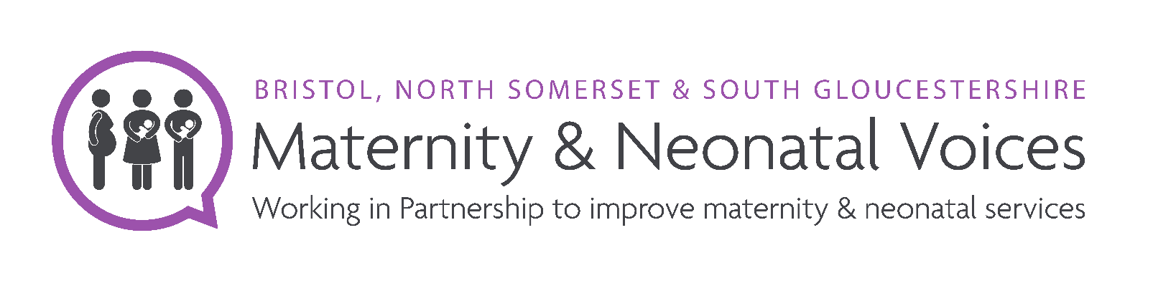
Job title – Project Officer

Location - Hybrid; office/ face to face meetings and home working.
Term - Fixed to March 31st 2026 25 days of leave entitlement (pro-rata) plus public holidays.
Starting salary - FTE £28,407.00 (£15,355.00).
Hours- 20 hours a week.
Responsible to - The Bristol, North Somerset and South Gloucestershire (BNSSG) Maternity and Neonatal Partnership (MNVP) Lead and Healthwatch BNSSG

Job purpose
Work with the Lead for MNVP in BNSSG, and leaders across the maternity system within NHS Trusts and the BNSSG area.
Work with acute trusts by facilitating coproduction with service users, families and carers on programmes, projects, and workstreams.
Support the MNVP Lead to represent women / birthing people and families from all communities within BNSSG, proactively seeking and encouraging the voices of minority and seldom heard community groups.
Ensure that women/birthing people and families are at the centre of safe and personalised maternity care in the Bristol, North Somerset, and South Gloucestershire Local Maternity and Neonatal System (LMNS).

Main duties and responsibilities
- Build and sustain partnerships with Maternity Services in BNSSG.
- Represent MNVP and service users, their partners and families at meetings with North Bristol Trust, University Hospitals Bristol and Weston Trust, and Sirona Health & Care relating to maternity services.
- Help to deliver MNVP workplan activity using coproduction with service-users.
- Provide collaboration on NHS Trust workstreams.
- Facilitate the delivery of the 15 Steps Challenge using the NHS toolkit.
- Prepare and manage the content of external communication to the public using social media, website and other relevant channels.
- Support MNVP BNSSG to collect, collate and share service-user insights to inform action plans, service change, redesign, and decision -making.
- Deputise for the Lead as required at meetings, events and Boards.
- Engage in 1:1 support/ reviews and undertake training where required.

General
To uphold the values and principles of working of the host organisation, Healthwatch BNSSG.

Maintain policies and adhere to requirements relating to equalities and diversity, mandatory training, DBS, confidentiality, safeguarding, information governance and data protection.

Collect performance and monitoring information to support the achievement of agreed targets and outcomes within workplans.

To undertake any such duties required by the MNVP Lead and those in your working agreement with Healthwatch including HR, financial governance and health and safety.

Person specification

This job description is not intended to be an exhaustive list but to indicate the main responsibilities. The role has a probation period, and employees will work flexibly throughout the year including school holiday and on other activities that may be requested. Partnership working will be in the hours 9-5pm Monday-Friday. There may be occasional evening and weekend work.

Qualifications and Knowledge | Essential | Desirable | Application/Interview
A sound, basic level of education and a commitment to relevant development | ü |  | A
Relevant qualification to level 3 standard or equivalent experience |  | ü | A & I
Knowledge and understanding of Equality, Diversity, Equity & Inclusion | ü |  | A & I
Understanding of how to engage with a diverse range of individuals and communities | ü |  | A & I
Understanding of health inequalities and the challenges faced by minority groups | ü |  | A & I
Understanding of the Health & Social Care sector within BNSSG |  | ü | A & I
Understanding of how to use a co-production approach |  | ü | A & I
Interest in women's, family and children's health |  | ü | A& I
Experience
Recent experience of maternity services (past 3 years) | ü
Working in partnership with health, social care and third sector organisations |  | ü | A & I
Work with minority groups and under-represented communities |  | ü | A & I
Maintaining notes and drafting reports |  | ü | A & I
Facilitation of groups / meetings |  | ü | A & I
Skills & competencies
Excellent communication and people skills | ü |  | A & I
Ability to work independently and with team support | ü |  | A & I
Good organisational skills with the ability to plan and prioritise | ü |  | A & I
Sensitivity, diplomacy, and a high degree of personal integrity | ü |  | I
Proficient in the use of IT, including the ability to use Microsoft Office 365 | ü |  | A & I
Proficient in use of social media for business |  |  | A & I
Ability to give presentations, lead discussions. | ü |  | A & I
Other/personal qualities
Ability to travel across the BNSSG area | ü |  | A & I
Reliable and flexible approach | ü |  | I

Full driving license and access to a vehicle, and the entitlement to work in the UK are essential.
You will need to pass a standard DBS check.

Applications

Applicants should not send CVs; use the application form provided to set how you meet the Job Description and Person Specification provided. Please send with your email the diversity monitoring record which will be separated from your application and kept securely and remain anonymous.

Please reply by 5pm Thursday 4th July 2024, to mnvp@bnssg.co.uk or post c/o Healthwatch BNSSG, Unit 21, Union Gallery (Middle Floor) The Galleries BS1 3XD

Interviews will be held face to face in the week beginning 15th July 2024. The interview panel will be a representative from the Local Maternity and Neonatal Service and Healthwatch BNSSG.

