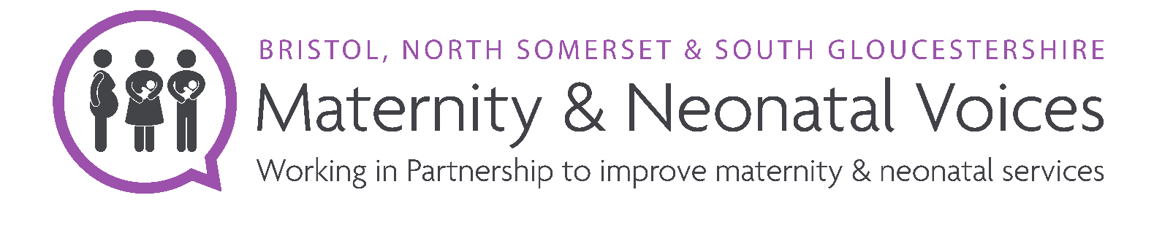
Job title - Community Engagement Officer
Location - Hybrid: office/ local community/ home working
Term - Fixed until 31st March 2026
Starting salary - £28,407.00 (£15,355.00 pro rata)
Hours - 20 hours a week, 25 days of leave entitlement (pro-rata) plus public holidays
Responsible to - The Bristol, North Somerset and South Gloucestershire (BNSSG) Maternity and Neonatal Partnership (MNVP) Lead and Healthwatch BNSSG
Role summary
To work with the MNVP Lead to embed an inclusive approach to understanding the health and care needs of residents and support the delivery of MNVP workplan priorities.
Work collaboratively with the Integrated Care Board’s (ICB) local services of Maternity and Neonatology (LMNS – Local Maternity and Neonatal System).
Engage with individuals, groups, and communities, particularly working to amplify those whose voices may be less heard.
Use a range of engagement and coproduction methods to gather information and listen to feedback from communities.
Build a network of connections with under-represented groups to ensure MNVP shares the voice of individuals to inform the improvement of services.
Record, collate and share accurate public feedback, produce professional reports, verbal & written briefings that affect the equity & inclusion of local services.
Job description
- To engage with individuals, groups, and communities, especially those that may be considered ‘harder to reach‘, gathering robust information about the needs and experiences of people using care services during their pregnancy and after the birth of their children.

- To ensure a community orientated and co-production approach is applied to consultation and project engagement.

- To effectively collaborate with partners and stakeholders in the voluntary, community and social enterprise sector.

- To use a diverse range of engagement and consultation techniques, adapting these to ensure they are appropriate for specific audiences.

- To provide written and verbal feedback to groups and meetings.

- To produce professional, accurate and informative report sharing intelligence with relevant partners and service providers.

- To use online systems for the recording of engagement feedback including demographics information.

- To maintain and provide information as required in relation to performance and outcomes monitoring.

- To represent MNVP at partnership events, networks, and forums where appropriate.

- To support individuals to obtain accurate information about relevant care services and refer to support services where appropriate.

- Be the point of contact for MNVP members and manage them as resources for activity and insights.

General

To uphold the values and principles of working of the host organisation, Healthwatch BNSSG.

Maintain policies and adhere to requirements relating to equalities and diversity, mandatory training, DBS, confidentiality, safeguarding, information governance and data protection.

To use creative techniques to gather views from all communities.

Collect performance and monitoring information to support the achievement of agreed targets and outcomes within workplans.

To undertake any such duties required by the MNVP Lead and those in your working agreement with Healthwatch including HR, financial governance and health and safety.

Person specification

This job description is not intended to be an exhaustive list but to indicate the main responsibilities. The role has a probation period, and employees will work flexibly throughout the year including school holiday and on other activities that may be requested. Partnership working will be in the hours 9-5pm Monday-Friday. There may be occasional evening and weekend work.

Qualifications and knowledge | Essential | Desirable | Application/Interview
A sound, basic level of education and a commitment to relevant development |  |  | A
Relevant qualification to level 3 standard (e.g. Health & Social Care) or equivalent experience |  |  | A
Knowledge and understanding of Equality & Diversity |  |  | A & I
Understanding of how to engage with a diverse range of individuals and communities |  |  | A & I
Understanding of health inequalities and the challenges faced by minority groups |  |  | A & I
Understanding of the Health & Social Care sector within BNSSG |  |  | A & I
Understanding of how to use a co-production approach |  |  | A & I
Interest in women's family and children's health |  |  | A & I
Experience
Recent experience of maternity services (last 3 years)
Working in partnership with health, social care and third sector organisations |  |  | A & I
Engaging with minority groups and underrepresented communities |  |  | A & I
Using a range of different methods to gather public opinion and feedback |  |  | A & I
Maintaining notes and drafting reports |  |  | A & I
Facilitation of groups / meetings |  |  | A & I
Coordination of volunteer members |  |  | A& I
Skills & competencies
Excellent communication and people skills |  |  | A & I
Commitment to ensuring representation for those individuals who are ‘harder to reach’ |  |  | A & I
Self-motivation and the ability to work without direct supervision |  |  | A & I
Good organisational skills with the ability to plan and prioritise |  |  | A & I
Sensitivity, diplomacy, and a high degree of personal integrity |  |  | I
Proficient in the use of IT, including the ability to use Microsoft Office 365 and survey software |  |  | A & I
Ability to lead discussions, develop and facilitate groups and gather relevant information |  |  | A & I
Other/personal qualities
Independently mobile with the ability to travel across the BNSSG area |  |  | A & I
Reliable and flexible approach |  |  | I
Commitment to personal development |  |  | I
Commitment to Equality, Diversity, Equity and Inclusion |  |  | A & I
Commitment to working as part of a team |  |  | A & I

Full driving license and access to a vehicle and entitlement to work in the UK are essential.
You will need to pass a standard DBS check.

Applications
Applicants should not send CVs but use the Form provided and set how you meet the Job Description and Person Specification provided. Please send the anonymous diversity monitoring record with your email, which will be separated from the form.
Closing date and time is 5pm Thursday 4th July 2024. Please send it to mnvp@bnssg.co.uk or post it c/o Healthwatch BNSSG, Unit 21, Union Gallery (Middle Floor) The Galleries BS1 3XD
Interviews will be held face to face in the week beginning 15th July 2024. The interview panel will be a representative from the Local Maternity and Neonatal Service and Healthwatch BNSSG.

