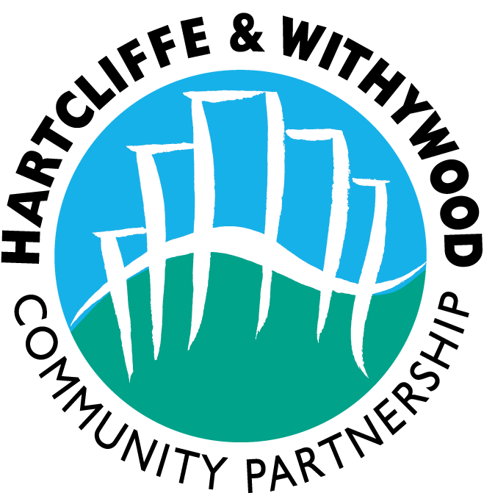

Hartcliffe and Withywood Community Partnership

Equal Opportunities Monitoring Form

Post: Domestic Abuse Community Co-ordinator

To assist us with the monitoring of equal opportunities, please answer the following questions. Please return by email with your application form.

1) Are you: Female Male

2) Do you consider yourself disabled? Yes No

3) Are you registered disabled? Yes No

- Do you have any special requirements? Yes No
Signer.......................
Access......................
Other (please specify)................................................

...............................................................................

- To which ethnic group would you say you belong? ..................

A1 Indian  A2 Pakistani  A3 Bangladeshi  A4 Chinese  A5 Asian Other | B1 Black African  B2 Black Caribbean  B3 Black UK  B4 Black Other | W1 White British  W2 White Irish  W3 White Other | M1 White and Black Caribbean  M2 White and Black African  M3 White and Asian  M4 Any other mixed background

If Other (please specify)............................................

- How did you hear about this post?........................................
If an internet website, please specify which one.

Date……………………………………………..

