Female* Crisis House Bank Night Support Worker

We have a rewarding opportunity available for Female Crisis House Bank Night Support Worker to join our team based in Bristol. You will join us as a Bank Night Support worker working ad hoc night shifts (some day shifts could be available). In return, you will receive a competitive salary of Point 9 £12.88 per hour for bank work and benefits.

Would you like to join the largest provider of women-only services in Bristol bringing innovation, expertise and extensive experience? Established in 1983, Bristol Missing Link incorporating Next Link and Safe Link) is a leading provider of women’s support services in Bristol.

In return for joining us, we will offer you the following fantastic benefits:

- Up to 30 days annual leave (depending on length of service)
- 3 extra holidays including International Women’s Day
- Excellent development and training opportunities
- Employer pension contribution (minimum 5% of your gross salary)
- Mindful Employer Plus Scheme
- Cycle to Work Scheme
- Long Service Awards

Please refer to our Employee Benefits leaflet which can be found in the application pack.

About the role:

We are looking for a positive and dynamic Female Crisis House Bank Night Support Worker who will work in our crisis house for women experiencing a mental health crisis and who are unable to cope in the community. Crisis House provides 24 hour support to women and works to a social care model of recovery. Successful candidates will be responsible for the support and safety of our service users.

Key duties and responsibilities of our Crisis House Night Support Worker:

- Provide practical and emotional support to women living in the Crisis House Service at night time.
- Ensure the security, safe and smooth running of the Crisis House during evenings and night time.
- Provide the highest possible standard of care and support to service users in accordance with the policies and procedures of Missing Link.
- Contribute to the overall aims and objectives of the Crisis House and facilitate service user recovery.
- Encourage and support night time routines.
- Carry out regular checks of the property throughout the night.
- Spend time with and support service users through the night.

This is not an exhaustive list of your duties and outlines the general ways in which it is expected you will meet the overall requirements of this post.

What we are looking for in our ideal Crisis House Night Support Worker:

- Experience of support planning and crisis prevention
- Experience of working in a support or care setting with people in mental health crisis
- Experience of managing emergency situations effectively
- Be able to work shifts between 9.30pm – 7.30am

If you are motivated, resourceful and passionate about empowering female victims of domestic abuse, please apply now to join us as our Crisis House Night Support Worker and contribute to the valuable work Missing Link and its wider services, delivering hope and support to survivors of domestic violence and abuse.

How to apply:

Please download the application pack from our website and complete the application form. Please submit your application by 9am on 12 July 2024. Please do not send CVs. Interviews will be held on 18 July 2024.

hr.enquiries@missinglinkhousing.co.uk www.missinglinkhousing.co.uk

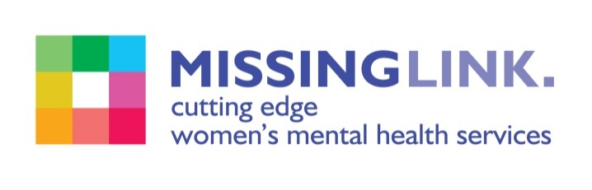
Missing Link is committed to safeguarding and promoting the welfare of children, young people and adults at risk of abuse, and expects all staff and volunteers to share this commitment. Missing Link is committed to Equal Opportunities. *Due to the specific requirements of this role, this post is exempt under the Equality Act (2010), Part 1, Schedule 9 (Genuine Occupational Requirement.)

