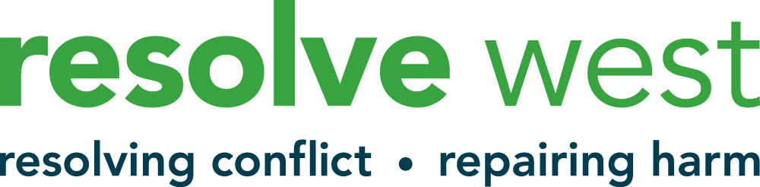

Confidential
Application to Volunteer with Resolve West

PERSONAL DETAILS

Name
Address
Postcode
Telephone
Email
Ward (if known)

Where did you hear of this opportunity?

Please tell us a bit about yourself, (Please tell us about your experience in work and/or volunteering, or some other relevant life experience. This could include your background, your home situation or perhaps about what interests you.

Please tell us about any current or previous paid or voluntary work that may be relevant to this role. (Please continue on a separate sheet as necessary)
Please tell us why you are interested in joining us as a volunteer? (Please continue on a separate sheet if necessary).
Please tell us about any training that you may have had that might be relevant to this role and volunteering in communities (ie safeguarding, child protection, mental health, addictions, equalities, trauma informed practice, etc
Do you have any additional skills you would bring to your role of volunteer, ie additional languages, BSL, therapeutic background, experience of coaching, supporting communities etc

What days and times are you available to volunteer? (We work with clients during the daytime, evening and sometimes at the weekend and expect you to be available to work on a minimum of 6 cases per year)

Do you have all the qualities and skills listed on the Facilitator job description/person specification enclosed in the Application Pack?
YES / NO (please delete)

Are you able to travel around Bristol and surrounding areas to meet with clients?
YES / NO (please delete)

Are you able to work face to face and also virtually on Zoom with clients?
YES / NO (please delete)

Are you over 18 years old?
YES / NO (please delete)

Do you agree to commit 96 hours per year for two years as a volunteer for us ?
YES / NO (please delete)

Please let us know who we should contact (two referees)
If you are successful following your interview, we would like to hear from two people who are able to comment on your potential to become a volunteer. These might be someone who knows you well in a work role, (paid and voluntary) or someone you know personally – but not family members.

Name: |  |  | Name
Email: |  |  | Email:
Phone: |  |  | Phone:
Address: |  |  | Address:
How do you know this person? |  |  | How do you know this person?

ACCESS NEEDS

Do you have any specific health/access requirements that will help you in the role of volunteer with resolve west? (if you would prefer to contact us by phone to discuss this prior to making this application let us know so we can arrange a call with you).

Data Protection (GDPR)
We take our duty to process your personal data very seriously. Our privacy statement explains how we collect, manage, use and protect your personal data.
https://resolvewest.org/privacy-statement/

DECLARATION (see note below)*
We work with young people and also vulnerable adultrs and therefore all of our volunteers need to undergo an Enhanced Disclosure and Barring Service check under the terms of the Rehabilitation of Offenders Act (1974).

Have you at any time been convicted of any criminal offence or been the subject of a caution, a bindover, or no case to answer? YES / NO (please delete)

If YES, please give details, including nature of offence on a separate sheet.

NB: The disclosure of an offence will not necessarily be a bar to your appointment.
(If you would prefer to contact us by phone to discuss this prior to making this application do let us know).

I hereby declare that the information I have given on this form are correct and I understand that if I have given any false information then my application will be refused.

Signed:
Name:
Date:

Please complete this form and the attached equalities form and return to:

sophie@resolvewest.org

Please contact Sophie, Volunteer Manager, at sophie@resolvewest.org for further information

We really look forward to receiving your application.

